* **Data Types in Java**

Data types specify the different sizes and values that can be stored in the variable. There are two types of data types in Java:

1. **Primitive data types:** The primitive data types include boolean, char, byte, short, int, long, float and double.
2. **Non-primitive data types:** The non-primitive data types include Classes, Interfaces, and Arrays.

**Java Primitive Data Types**

In Java language, primitive data types are the building blocks of data manipulation. These are the most basic data types available in Java language.

There are 8 types of primitive data types:

* boolean data type
* byte data type
* char data type
* short data type
* int data type
* long data type
* float data type
* double data type

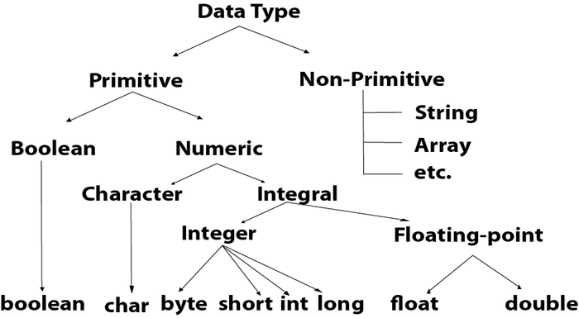

|  |  |  |
| --- | --- | --- |
| **Data Type** | **Default Value** | **Default size** |
| Boolean | false | 1 bit |
| Char | '\u0000' | 2 byte |
| Byte | 0 | 1 byte |
| Short | 0 | 2 byte |
| Int | 0 | 4 byte |
| Long | 0L | 8 byte |
| Float | 0.0f | 4 byte |
| Double | 0.0d | 8 byte |

## Boolean Data Type

The Boolean data type is used to store only two possible values: true and false. This data type is used for simple flags that track true/false conditions.

The Boolean data type specifies one bit of information, but its "size" can't be defined precisely.

**Example:** Boolean one = false

## Byte Data Type

The byte data type is an example of primitive data type. It isan 8-bit signed two's complement integer. Its value-range lies between -128 to 127 (inclusive). Its minimum value is -128 and maximum value is 127. Its default value is 0.

The byte data type is used to save memory in large arrays where the memory savings is most required. It saves space because a byte is 4 times smaller than an integer. It can also be used in place of "int" data type.

**Example:** byte a = 10, byte b = -20

## Short Data Type

The short data type is a 16-bit signed two's complement integer. Its value-range lies between -32,768 to 32,767 (inclusive). Its minimum value is -32,768 and maximum value is 32,767. Its default value is 0.

The short data type can also be used to save memory just like byte data type. A short data type is 2 times smaller than an integer.

**Example:** short s = 10000, short r = -5000

## Int Data Type

The int data type is a 32-bit signed two's complement integer. Its value-range lies between - 2,147,483,648 (-2^31) to 2,147,483,647 (2^31 -1) (inclusive). Its minimum value is - 2,147,483,648and maximum value is 2,147,483,647. Its default value is 0.

The int data type is generally used as a default data type for integral values unless if there is no problem about memory.

**Example:** int a = 100000, int b = -200000

## Long Data Type

The long data type is a 64-bit two's complement integer. Its value-range lies between -9,223,372,036,854,775,808(-2^63) to 9,223,372,036,854,775,807(2^63 -1)(inclusive). Its minimum value is - 9,223,372,036,854,775,808and maximum value is 9,223,372,036,854,775,807. Its default value is 0. The long data type is used when you need a range of values more than those provided by int.

**Example:** long a = 100000L, long b = -200000L

## Float Data Type

The float data type is a single-precision 32-bit IEEE 754 floating point.Its value range is unlimited. It is recommended to use a float (instead of double) if you need to save memory in large arrays of floating point numbers. The float data type should never be used for precise values, such as currency. Its default value is 0.0F.

**Example:** float f1 = 234.5f

## Double Data Type

The double data type is a double-precision 64-bit IEEE 754 floating point. Its value range is unlimited. The double data type is generally used for decimal values just like float. The double data type also should never be used for precise values, such as currency. Its default value is 0.0d.

**Example:** double d1 = 12.3

## Char Data Type

The char data type is a single 16-bit Unicode character. Its value-range lies between '\u0000' (or 0) to '\uffff' (or 65,535 inclusive).The char data type is used to store characters.

**Example:** char letterA = 'A'

### Why char uses 2 byte in java and what is \u0000 ?

It is because java uses Unicode system not ASCII code system. The \u0000 is the lowest range of Unicode system. To get detail explanation about Unicode visit next page.

Java Naming conventions

Java naming convention is a rule to follow as you decide what to name your identifiers such as class, package, variable, constant, method, etc.

But, it is not forced to follow. So, it is known as convention not rule. These conventions are suggested by several Java communities such as Sun Microsystems and Netscape.

All the classes, interfaces, packages, methods and fields of Java programming language are given according to the Java naming convention. If you fail to follow these conventions, it may generate confusion or erroneous code.

### Class

* It should start with the uppercase letter.
* It should be a noun such as Color, Button, System, Thread, etc.
* Use appropriate words, instead of acronyms.

### Interface

* It should start with the uppercase letter.
* It should be an adjective such as Runnable, Remote, ActionListener.
* Use appropriate words, instead of acronyms.

### Method

* It should start with lowercase letter.
* It should be a verb such as main(), print(), println().
* If the name contains multiple words, start it with a lowercase letter followed by an uppercase letter such as actionPerformed().

### Variable

* It should start with a lowercase letter such as id, name.
* It should not start with the special characters like & (ampersand), $ (dollar), _ (underscore).
* If the name contains multiple words, start it with the lowercase letter followed by an uppercase letter such as firstName, lastName.
* Avoid using one-character variables such as x, y, z.

### Package

* It should be a lowercase letter such as java, lang.
* If the name contains multiple words, it should be separated by dots (.) such as java.util, java.lang.

### Constant

* It should be in uppercase letters such as RED, YELLOW.
* If the name contains multiple words, it should be separated by an underscore(_) such as MAX_PRIORITY.
* It may contain digits but not as the first letter.

Objects and Classes in Java

**Object-**An entity that has state and behavior is known as an object e.g., chair, bike, marker, pen, table, car, etc. It can be physical or logical (tangible and intangible). The example of an intangible object is the banking system.

An object has three characteristics:

* **State:** represents the data (value) of an object.
* **Behavior:** represents the behavior (functionality) of an object such as deposit, withdraw, etc.
* **Identity:** An object identity is typically implemented via a unique ID. The value of the ID is not visible to the external user. However, it is used internally by the JVM to identify each object uniquely.

**Object Definition:**

* An object is *a real-world entity*.

What is a class in Java

A class is a group of objects which have common properties. It is a template or blueprint from which objects are created. It is a logical entity. It can't be physical.

A class in Java can contain:

* **Fields**
* **Methods**
* **Constructors**
* **Blocks**
* **Nested class and interface**

### Syntax to declare a class:

**class** <class_name>{

    field;

    method;

}

### new keyword in Java

The new keyword is used to allocate memory at runtime. All objects get memory in Heap memory area.

### Object and Class Example: main within the class

In this example, we have created a Student class which has two data members id and name. We are creating the object of the Student class by new keyword and printing the object's value.

Here, we are creating a main() method inside the class.

*File: Student.java*

**Java Program to illustrate how to define a class and fields**

.

**class** Student

{

**int** id;

 String name;

**public** **static** **void** main(String args[]){

  Student s1=**new** Student(); //creating an object of Student

  System.out.println(s1.id);

  System.out.println(s1.name);

 }

}

Wrapper classes in Java

The **wrapper class in Java** provides the mechanism *to convert primitive into object and object into primitive*.

Since J2SE 5.0, **autoboxing** and **unboxing** feature convert primitives into objects and objects into primitives automatically. The automatic conversion of primitive into an object is known as autoboxing and vice-versa unboxing.

Use of Wrapper classes in Java

Java is an object-oriented programming language, so we need to deal with objects many times like in Collections, Serialization, Synchronization, etc. Let us see the different scenarios, where we need to use the wrapper classes.

* **Change the value in Method:** Java supports only call by value. So, if we pass a primitive value, it will not change the original value. But, if we convert the primitive value in an object, it will change the original value.
* **Serialization:** We need to convert the objects into streams to perform the serialization. If we have a primitive value, we can convert it in objects through the wrapper classes.
* **Synchronization:** Java synchronization works with objects in Multithreading.
* **java.util package:** The java.util package provides the utility classes to deal with objects.
* **Collection Framework:** Java collection framework works with objects only. All classes of the collection framework (ArrayList, LinkedList, Vector, HashSet, LinkedHashSet, TreeSet, PriorityQueue, ArrayDeque, etc.) deal with objects only.

The eight classes of the *java.lang* package are known as wrapper classes in Java. The list of eight wrapper classes are given below:

|  |  |
| --- | --- |
| **Primitive Type** | **Wrapper class** |
| Boolean | [Boolean](https://www.javatpoint.com/java-boolean) |
| Char | [Character](https://www.javatpoint.com/post/java-character) |
| Byte | [Byte](https://www.javatpoint.com/java-byte) |
| Short | [Short](https://www.javatpoint.com/java-short) |
| Int | [Integer](https://www.javatpoint.com/java-integer) |
| Long | [Long](https://www.javatpoint.com/java-long) |
| Float | [Float](https://www.javatpoint.com/java-float) |
| Double | [Double](https://www.javatpoint.com/java-double) |

Autoboxing

The automatic conversion of primitive data type into its corresponding wrapper class is known as autoboxing, for example, byte to Byte, char to Character, int to Integer, long to Long, float to Float, boolean to Boolean, double to Double, and short to Short.

Since Java 5, we do not need to use the valueOf() method of wrapper classes to convert the primitive into objects.

**Wrapper class Example: Primitive to Wrapper**

//Java program to convert primitive into objects

//Autoboxing example of int to Integer

**public** **class** WrapperExample1{

**public** **static** **void** main(String args[]){

//Converting int into Integer

**int** a=20;

Integer i=Integer.valueOf(a);//converting int into Integer explicitly

Integer j=a;//autoboxing, now compiler will write Integer.valueOf(a) internally

System.out.println(a+" "+i+" "+j);

}}

Output:

20 20 20

Unboxing

The automatic conversion of wrapper type into its corresponding primitive type is known as unboxing. It is the reverse process of autoboxing. Since Java 5, we do not need to use the intValue() method of wrapper classes to convert the wrapper type into primitives.

**Wrapper class Example: Wrapper to Primitive**

//Java program to convert object into primitives

//Unboxing example of Integer to int

**public** **class** WrapperExample2{

**public** **static** **void** main(String args[]){

//Converting Integer to int

Integer a=**new** Integer(3);

**int** i=a.intValue();//converting Integer to int explicitly

**int** j=a;//unboxing, now compiler will write a.intValue() internally

System.out.println(a+" "+i+" "+j);

}}

Output:

3 3 3

Access Modifiers in Java

There are two types of modifiers in Java: **access modifiers** and **non-access modifiers**.

The access modifiers in Java specifies the accessibility or scope of a field, method, constructor, or class. We can change the access level of fields, constructors, methods, and class by applying the access modifier on it.

There are four types of Java access modifiers:

1. **Private**: The access level of a private modifier is only within the class. It cannot be accessed from outside the class.
2. **Default**: The access level of a default modifier is only within the package. It cannot be accessed from outside the package. If you do not specify any access level, it will be the default.
3. **Protected**: The access level of a protected modifier is within the package and outside the package through child class. If you do not make the child class, it cannot be accessed from outside the package.
4. **Public**: The access level of a public modifier is everywhere. It can be accessed from within the class, outside the class, within the package and outside the package.

There are many non-access modifiers, such as static, abstract, synchronized, native, volatile, transient, etc. Here, we are going to learn the access modifiers only.

### Understanding Java Access Modifiers

Let's understand the access modifiers in Java by a simple table.

|  |  |  |  |  |
| --- | --- | --- | --- | --- |
| **Access Modifier** | **within class** | **within package** | **outside package by subclass only** | **outside package** |
| **Private** | Y | N | N | N |
| **Default** | Y | Y | N | N |
| **Protected** | Y | Y | Y | N |
| **Public** | Y | Y | Y | Y |

**Note – refer class notes for access modifier programs**

Java static keyword

The **static keyword** in Java is used for memory management mainly. We can apply java static keyword with variables, methods, blocks and nested class. The static keyword belongs to the class than an instance of the class.

The static can be:

1. Variable (also known as a class variable)
2. Method (also known as a class method)
3. Block
4. Nested class

## 1) Java static variable

If you declare any variable as static, it is known as a static variable.

* The static variable can be used to refer to the common property of all objects (which is not unique for each object), for example, the company name of employees, college name of students, etc.
* The static variable gets memory only once in the class area at the time of class loading.

### Advantages of static variable

It makes your program **memory efficient** (i.e., it saves memory).

#### Understanding the problem without static variable

**class** Student{

**int** rollno;

     String name;

     String college="ITS";

}

Suppose there are 500 students in my college, now all instance data members will get memory each time when the object is created. All students have its unique rollno and name, so instance data member is good in such case. Here, "college" refers to the common property of all objects. If we make it static, this field will get the memory only once.

#### Java static property is shared to all objects.

### Note – refer class notes for static keyword programs

# Java Arrays

Normally, an array is a collection of similar type of elements which have a contiguous memory location.

**Java array** is an object which contains elements of a similar data type. Additionally, The elements of an array are stored in a contiguous memory location. It is a data structure where we store similar elements. We can store only a fixed set of elements in a Java array.

Array in Java is index-based, the first element of the array is stored at the 0th index, 2nd element is stored on 1st index and so on.

Unlike C/C++, we can get the length of the array using the length member. In C/C++, we need to use the sizeof operator.

In Java, array is an object of a dynamically generated class. Java array inherits the Object class, and implements the Serializable as well as Cloneable interfaces. We can store primitive values or objects in an array in Java. Like C/C++, we can also create single dimentional or multidimentional arrays in Java.

Moreover, Java provides the feature of anonymous arrays which is not available in C/C++.

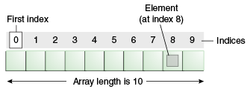

### Advantages

* **Code Optimization:** It makes the code optimized, we can retrieve or sort the data efficiently.
* **Random access:** We can get any data located at an index position.

### Disadvantages

* **Size Limit:** We can store only the fixed size of elements in the array. It doesn't grow its size at runtime. To solve this problem, collection framework is used in Java which grows automatically.

### Types of Array in java

There are two types of array.

* Single Dimensional Array
* Multidimensional Array

## Single Dimensional Array in Java

**Syntax to Declare an Array in Java**

1. dataType[] arr; (or)
2. dataType []arr; (or)
3. dataType arr[];

**Instantiation of an Array in Java**

1. arrayRefVar=**new** datatype[size];

### Example of Java Array

Let's see the simple example of java array, where we are going to declare, instantiate, initialize and traverse an array.

//Java Program to illustrate how to declare, instantiate, initialize

//and traverse the Java array.

**class** Testarray{

**public** **static** **void** main(String args[]){

**int** a[]=**new** **int**[5];//declaration and instantiation

a[0]=10;//initialization

a[1]=20;

a[2]=70;

a[3]=40;

a[4]=50;

//traversing array

**for**(**int** i=0;i<a.length;i++)//length is the property of array

System.out.println(a[i]);

}}

Declaration, Instantiation and Initialization of Java Array

We can declare, instantiate and initialize the java array together by:

1. **int** a[]={33,3,4,5};//declaration, instantiation and initialization

## Multidimensional Array in Java

In such case, data is stored in row and column based index (also known as matrix form).

**Syntax to Declare Multidimensional Array in Java**

1. dataType[][] arrayRefVar; (or)
2. dataType [][]arrayRefVar; (or)
3. dataType arrayRefVar[][]; (or)
4. dataType []arrayRefVar[];

**Example to instantiate Multidimensional Array in Java**

1. **int**[][] arr=**new** **int**[3][3];//3 row and 3 column

**Example to initialize Multidimensional Array in Java**

1. arr[0][0]=1;
2. arr[0][1]=2;
3. arr[0][2]=3;
4. arr[1][0]=4;
5. arr[1][1]=5;
6. arr[1][2]=6;
7. arr[2][0]=7;
8. arr[2][1]=8;
9. arr[2][2]=9;

### Example of Multidimensional Java Array

Let's see the simple example to declare, instantiate, initialize and print the 2Dimensional array.

//Java Program to illustrate the use of multidimensional array

**class** Testarray3{

**public** **static** **void** main(String args[]){

//declaring and initializing 2D array

**int** arr[][]={{1,2,3},{2,4,5},{4,4,5}};

//printing 2D array

**for**(**int** i=0;i<3;i++){

**for**(**int** j=0;j<3;j++){

   System.out.print(arr[i][j]+" ");

 }

 System.out.println();

}

}}

Jagged Array in Java

If we are creating odd number of columns in a 2D array, it is known as a jagged array. In other words, it is an array of arrays with different number of columns.

//Java Program to illustrate the jagged array

**class** TestJaggedArray{

**public** **static** **void** main(String[] args){

        //declaring a 2D array with odd columns

**int** arr[][] = **new** **int**[3][];

        arr[0] = **new** **int**[3];

        arr[1] = **new** **int**[4];

        arr[2] = **new** **int**[2];

        //initializing a jagged array

**int** count = 0;

**for** (**int** i=0; i<arr.length; i++)

**for**(**int** j=0; j<arr[i].length; j++)

                arr[i][j] = count++;

        //printing the data of a jagged array

**for** (**int** i=0; i<arr.length; i++){

**for** (**int** j=0; j<arr[i].length; j++){

                System.out.print(arr[i][j]+" ");

            }

            System.out.println();//new line

        }

    }

}

# Exception Handling in Java

1. [Exception Handling](https://www.javatpoint.com/exception-handling-in-java)
2. [Advantage of Exception Handling](https://www.javatpoint.com/exception-handling-in-java#exceptionad)
3. [Hierarchy of Exception classes](https://www.javatpoint.com/exception-handling-in-java#exceptionhierarchy)
4. [Types of Exception](https://www.javatpoint.com/exception-handling-in-java#exceptiontypes)
5. [Exception Example](https://www.javatpoint.com/exception-handling-in-java#exceptionexample)
6. [Scenarios where an exception may occur](https://www.javatpoint.com/exception-handling-in-java#exceptionscenarios)

The **Exception Handling in Java** is one of the powerful mechanism to handle the runtime errors so that normal flow of the application can be maintained.

In this page, we will learn about Java exceptions, its type and the difference between checked and unchecked exceptions.

## What is Exception in Java

**Dictionary Meaning:** Exception is an abnormal condition.

In Java, an exception is an event that disrupts the normal flow of the program. It is an object which is thrown at runtime.

## What is Exception Handling

Exception Handling is a mechanism to handle runtime errors such as ClassNotFoundException, IOException, SQLException, RemoteException, etc.

### Advantage of Exception Handling

The core advantage of exception handling is **to maintain the normal flow of the application**. An exception normally disrupts the normal flow of the application that is why we use exception handling. Let's take a scenario:

1. statement 1;
2. statement 2;
3. statement 3;
4. statement 4;
5. statement 5;//exception occurs
6. statement 6;
7. statement 7;
8. statement 8;
9. statement 9;
10. statement 10;

Suppose there are 10 statements in your program and there occurs an exception at statement 5, the rest of the code will not be executed i.e. statement 6 to 10 will not be executed. If we perform exception handling, the rest of the statement will be executed. That is why we use exception handling in Java.

## Hierarchy of Java Exception classes

The java.lang.Throwable class is the root class of Java Exception hierarchy which is inherited by two subclasses: Exception and Error. A hierarchy of Java Exception classes are given below:

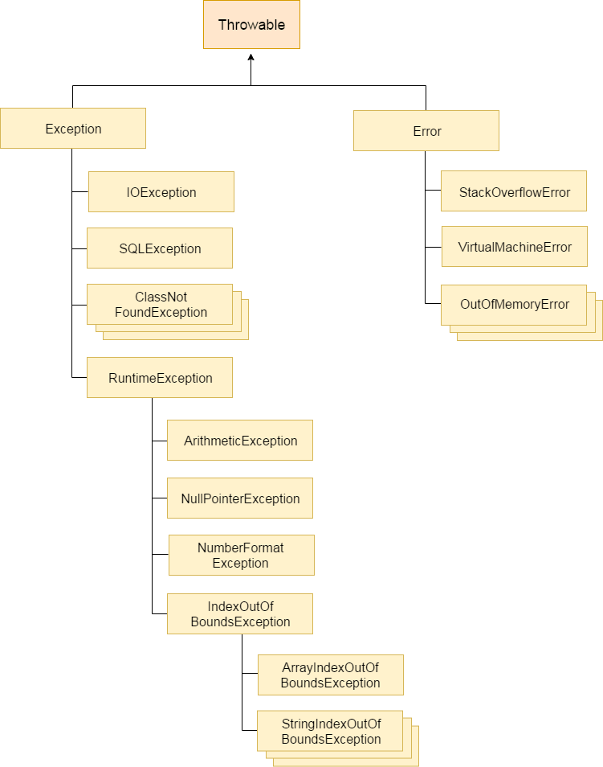

### Types of Java Exceptions

There are mainly two types of exceptions: checked and unchecked. Here, an error is considered as the unchecked exception. According to Oracle, there are three types of exceptions:

1. Checked Exception
2. Unchecked Exception
3. Error

## Difference between Checked and Unchecked Exceptions

### 1) Checked Exception

The classes which directly inherit Throwable class except RuntimeException and Error are known as checked exceptions e.g. IOException, SQLException etc. Checked exceptions are checked at compile-time.

### 2) Unchecked Exception

The classes which inherit RuntimeException are known as unchecked exceptions e.g. ArithmeticException, NullPointerException, ArrayIndexOutOfBoundsException etc. Unchecked exceptions are not checked at compile-time, but they are checked at runtime.

### 3) Error

Error is irrecoverable e.g. OutOfMemoryError, VirtualMachineError, AssertionError etc.

Java Exception Keywords

There are 5 keywords which are used in handling exceptions in Java

|  |  |
| --- | --- |
| **Keyword** | **Description** |
| try | The "try" keyword is used to specify a block where we should place exception code. The try block must be followed by either catch or finally. It means, we can't use try block alone. |
| catch | The "catch" block is used to handle the exception. It must be preceded by try block which means we can't use catch block alone. It can be followed by finally block later. |
| finally | The "finally" block is used to execute the important code of the program. It is executed whether an exception is handled or not. |
| throw | The "throw" keyword is used to throw an exception. |
| throws | The "throws" keyword is used to declare exceptions. It doesn't throw an exception. It specifies that there may occur an exception in the method. It is always used with method signature. |

**Note : for exception handling programs refer exception handling ppt**